**STAT 40001/STAT 59800 Statistical Computing Fall 2020**

**Lab-6**

**Q.N. 1)** The Weight of Euro Coins: Its Distribution Might Not Be As Normal As You Would Expect written by Shkedy et al. is an article published in Journal of Statistics Education Volume 14, Number 2 (2006).

Go to <http://www.amstat.org/publications/jse/datasets/euroweight.dat.txt>

a) Import the ***euroweight.dat.txt*** data in R.

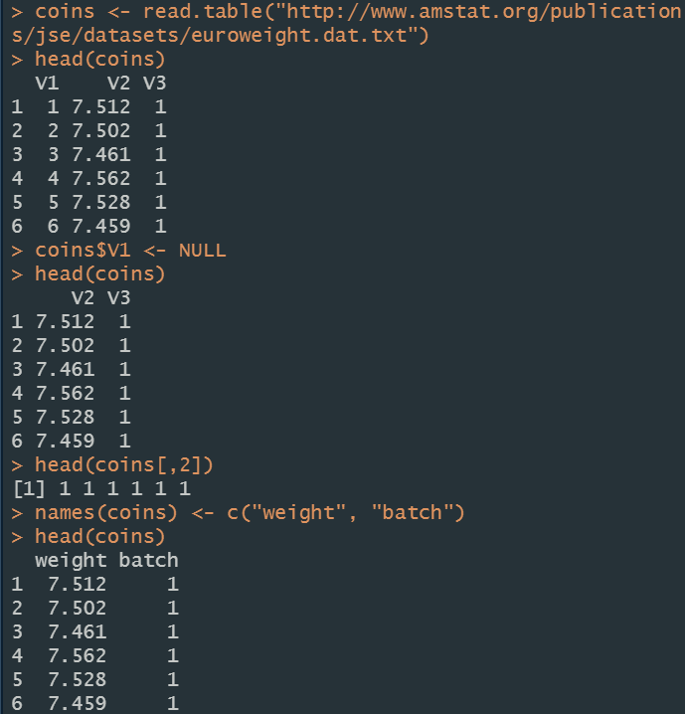

b) Select the third column batch of the coins.



c) Create the frequency table of the batch of the coins.

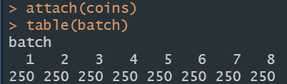

d) Calculate the aggregate means of each batch.

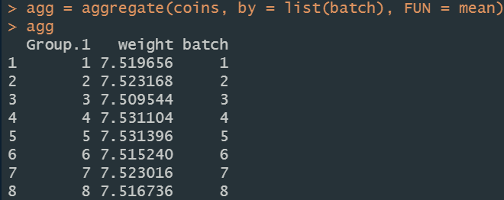

**Q.N. 2)** Create a pie chart displaying the information given below and save it

|  |  |
| --- | --- |
| Types of Housing | Frequency |
| Apartment | 20 |
| Dorm | 15 |
| House | 9 |
| Sorority/Fraternity House | 5 |

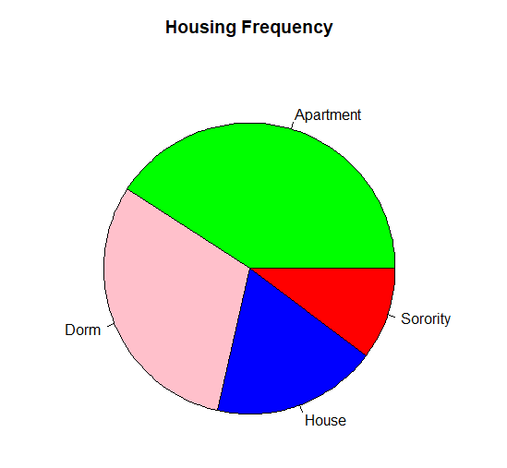

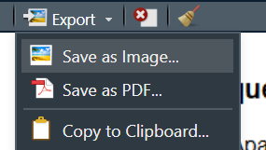

**Q.N. 3)** Go to <http://www.amstat.org/publications/jse/jse_data_archive.htm>

a) Import the babyboom.dat.txt data



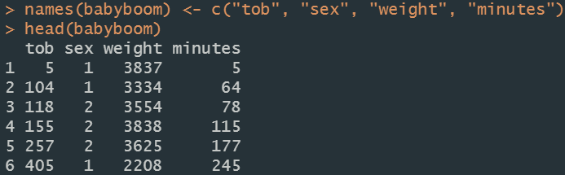

b) Select the column with the birth weight of new born babies.

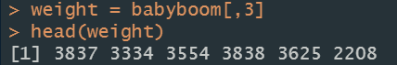

c) Create a histogram of the subject data.



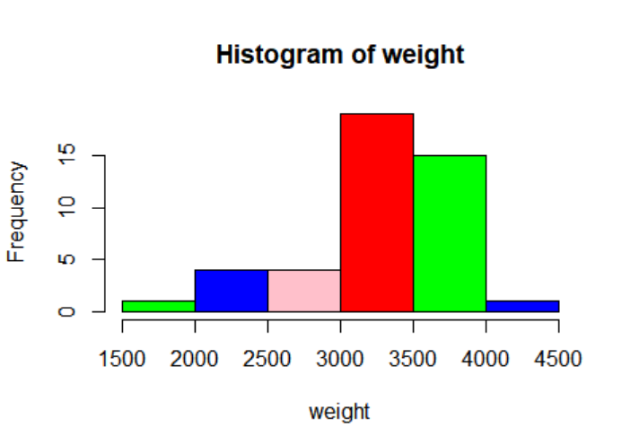

**Q.N. 4)** The link below provides a data file *homes* which includes monthly data regarding the number of new single-family houses sold in the U.S. in thousands(homes) and 30 year conventional mortgage rate (irate) from January, 1992 to March, 2010.

<http://www.principlesofeconometrics.com/poe4/poe4stata.htm>

1. Import the data in R

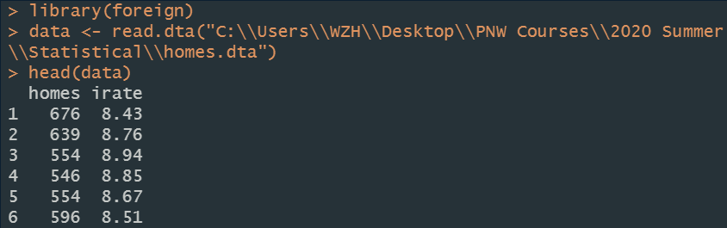

1. Calculate the five number summary of homes and irate



1. Draw a scatterplot to display the data.



